Omar Ahmad

EE 180DA

Lab 1A

Week 10 report

This week, I planned to integrate my sequence bitmap program with my labmates’ Bluetooth connection scripts. I also planned to write a client/slave script to output on/off according to its location.

I completed the slave script. It takes in as a command line argument a csv file full of 1’s and 0’s and a TIME parameter. It then output’s on or off every TIME seconds according to the csv.

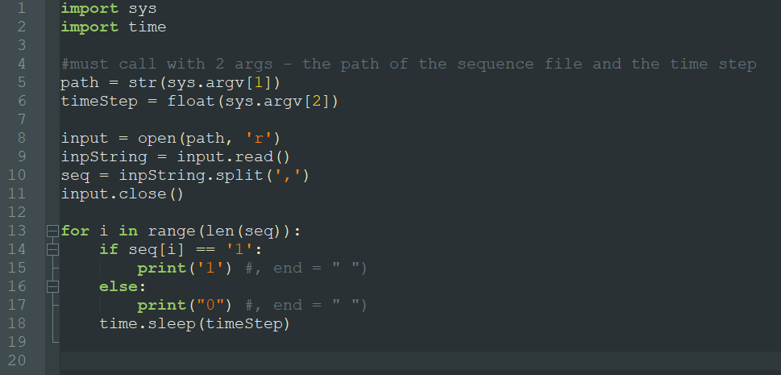

Today, I plan to integrate my code with my groupmates’ Bluetooth connection code and work on setting up a demo for the final presentation.